

5615 Deauville Blvd., Suite 100

Midland, TX 79706

(432) 221-3040

Scheduling

P: (432) 221-2300

F: (432) 221-4926

**Patient Name: _________________________ Date of Birth:__________________**

**Patient Contact Number:** _________________

Examination Requested:

Genetics Consultation

High Risk Consultation

Screening Mammogram and Screening U/S for Dense Breast PRN----circle one: Right/Left/Bilateral/PRN

**€** Diagnostic Mammogram-------------------------------------------------------------circle one: Right / Left / Bilateral / PRN

**€** Diagnostic Breast Ultrasound--------------------------------------------------------circle one: Right / Left / Bilateral / PRN

**€** MRI Breast with and without Contrast

**€** Biopsy: Stereotactic / Ultrasound / MRI / Tomo guided -------------------------------------------circle one:

Right / Left / Bilateral

**€** Needle Localization: Kopan’s Wire------------------------------------------------ circle one: Right / Left / Bilateral

**€** Needle Localization: Savi Scout------ --------------------------------------------- circle one: Right / Left / Bilateral

**€** Bone Mineral Density

History / Clinical Information (Please send previous films): _______________________________________________

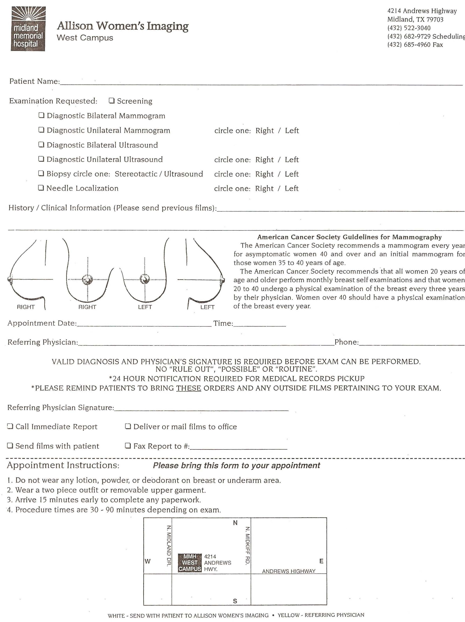

**Appointment Date: _____________________ Time: ___________**

Referring Provider: __________________________________________________________ Phone: ____________________

Referring Provider Signature: ___________________________________________ Fax Report To:____________________

VALID DIAGNOSIS AND PROVIDER’S SIGNATURE IS REQUIRED BEFORE THE EXAM CAN BE PERFORMED.

NO “RULE OUT,” POSSIBLE,” OR “ROUTINE.”

*24 HOUR NOTIFICATION REQUIRED FOR MEDICAL RECORDS PICKUP

* PLEASE REMIND PATIENTS TO BRING THESE ORDERS AND ANY OUTSIDE FILMS PERTINENT TO THE EXAM.

**Appointment Instructions:** ***Please bring this form to your appointment.***

**1. Do not wear any lotion, powder, or deodorant on the breast or underarm area.**

**2. Wear a two-piece outfit or removable upper garment.**

**3. Arrive 15 minutes early to complete paperwork.**

**4. Procedure times are 30-90 minutes depending on the exam.**

The following requests are being made by us in order to comply with **State and Federal regulations** and to serve you and your loved ones to the best of our ability. Children are not allowed in the exam rooms unless they are having an examination done. One parent is allowed in the room during the exam for small children. Children may not be left unattended in the lobby area. Please arrange to have someone watch them during your examination. When an older child or adult is having an exam, only that patient is allowed in the exam room, unless there is a special need for assistance. Loved ones are welcome to stay in our lobby during the exam. We ask that you turn off cell phones while you are here.

**Screening Mammography**

A screening mammogram is for those who do not have a specific breast concern or symptom, such as a lump. A screening mammogram is a special x-ray that takes a picture of the inside of the breast. A screening mammogram is used as the best way for most women to find cancers early, when they are small, and are very treatable. Our facility utilizes 3D Mammography, also known as Tomosynthesis.

**Screening Ultrasound**

A screening ultrasound may be suggested when a woman has dense breast tissue that might hide breast abnormalities.

**Diagnostic Mammography**

Patients with symptoms such as a palpable lump, discharge, etc. will be scheduled for a diagnostic mammogram. If a screening mammogram has found a suspicious area, you will be called back for a diagnostic mammogram. During this exam, more images are taken than in a screening mammogram. The x-rays will be more focused on the area of concern.

**Diagnostic Ultrasound**

Patients with symptoms such as a palpable lump, discharge, etc. will be scheduled for a diagnostic ultrasound. A diagnostic ultrasound is also performed when an abnormality is found on a mammogram.

**MRI**

Breast MRI uses magnetic fields to create an image of the breast. It is more sensitive than a mammogram due to the use of IV contrast material that will be administered during the exam. MRI is a very sensitive and useful for assessing invasive carcinomas. It is also used to assess high-risk patients who have a 15-20 or greater percent chance of developing breast cancer in their lifetimes based on genetics and a strong family history of breast cancer.

**Biopsy Services**

A biopsy is the only sure way to diagnose breast cancer. A biopsy removes some cells from the area of concern, so they can be checked under the microscope by the Pathologist. There are several different biopsy types. The choice of which type to use depends on several different factors like how suspicious the tumor looks, how big it is, and the location in your breast. Local anesthesia is used with this procedure.

**Needle Localization**

This procedure can be performed under ultrasound or by mammography. The radiologist inserts a very thin wire or Savi Scout reflector into the breast where the lesion is located. This wire or reflector serves as a road map for the breast surgeon to take out tissue at or near the region of interest.  Local anesthesia is used with this procedure.

**Bone Density Testing**

A bone density test is used to diagnose osteoporosis before a broken bone occurs. This test helps to estimate the density of your bones and your chance of breaking a bone. Bone Density testing is a low dose x-ray that determines the amount of calcium and other minerals in the bone.

